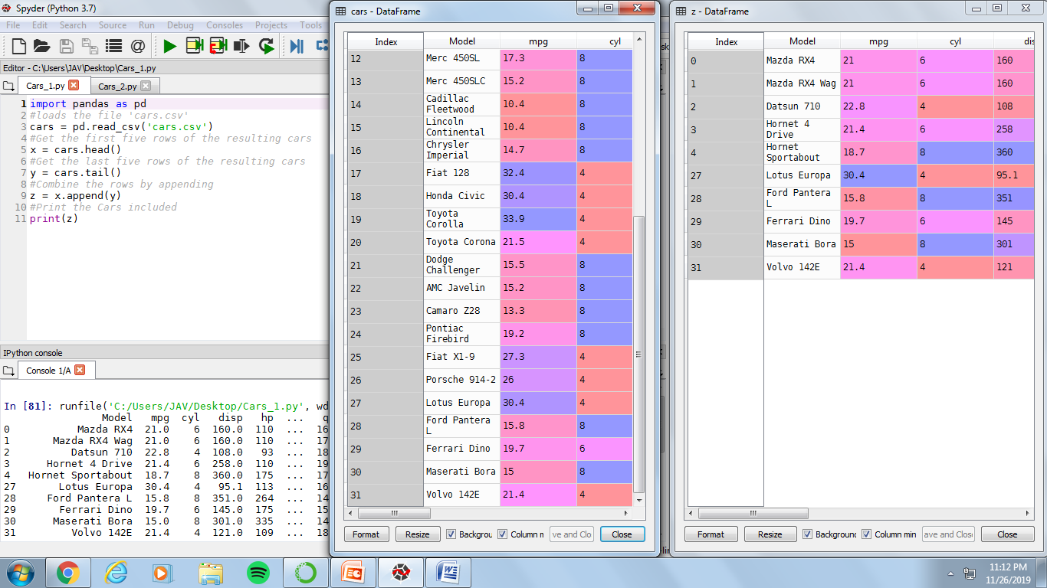VILLAR, VINCE Q. PROGRAMMING ASSIGNMENT

2-ECE-D PANDAS

**PROBLEM 1**

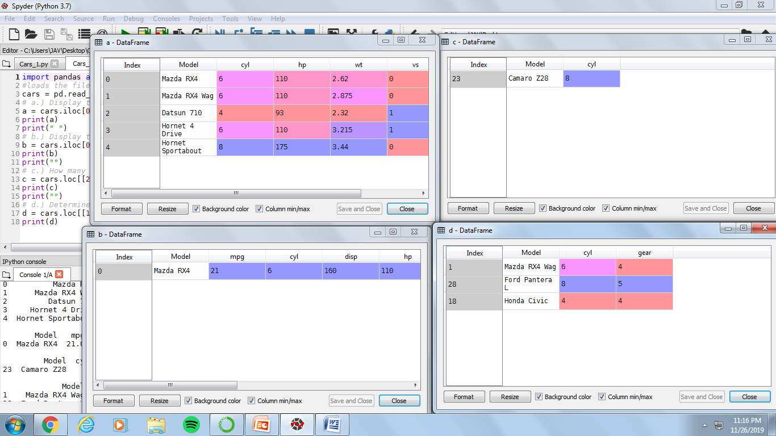**PROBLEM 2**